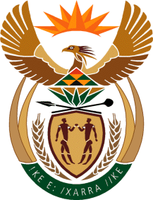

MINISTRY: COMMUNICATIONS
REPUBLIC OF SOUTH AFRICA
Private Bag X 745, Pretoria, 0001, Tel: +27 12 473 0164 Fax: +27 12 473 0585
Tshedimosetso House,1035 Francis Baard Street, Tshedimosetso House, Pretoria, 1000

NATIONAL ASSEMBLY
QUESTION FOR WRITTEN REPLY
QUESTION NUMBER: 3362
DATE OF PUBLICATION: 04 SEPTEMBER 2015
M Mr G R Davis (DA) to ask the Minister of Communications:
Whether, with reference to her reply to question 2855 on 26 August 2015, a reporter accompanied her on her trip to the Atlanta Lifestyle Hub Show and Sante FE Folk Art Festival in July 2015; if not, what is her position regarding a report in a certain online publication of 10 July 2015 (details furnished); if so, (a) what was the name of the reporter, (b) what organisation does the reporter represent, (c) what was the purpose of taking the reporter with her on the specified trip, (d) who paid for the reporter to accompany her, (e) what amount did it cost for the reporter to accompany her and (f) what amount did her department spend on (aa) flights, (bb) accommodation and (cc) other expenses in respect of the reporter? NW4021E

REPLY: DEPARTMENT OF COMMUNICATIONS
Minister was only accompanied by officials from the Ministry/Department of Communications.

MR NN MUNZHELELE
DIRECTOR GENERAL [ACTING]
DEPARTMENT OF COMMUNICATIONS
DATE:

MS AF MUTHAMBI (MP)
MINISTER OF COMMUNICATIONS
DATE

