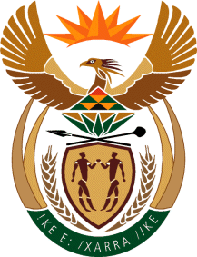
MINISTRY
SPORT AND RECREATION
REPUBLIC OF SOUTH AFRICA

Department of Sport and Recreation l Private Bag X896 l PRETORIA l 0001 l Regent Place l 66 Queen Street l Pretoria l 0001 l +27 (0)12 304 5158 l Fax: +27 (0)12 323 8426
Private Bag X9149 l Cape Town l 8000 l 2nd Floor Parliament Building l 120 Plain Street l CAPE TOWN l Tel: +27 21 469 5705 l Fax: +27 21 465 4402
www.srsa.gov.za
_____________________________________________________________________

NATIONAL ASSEMBLY

WRITTEN REPLY

QUESTION PAPER: No. 39 of 27 OCTOBER 2017

DATE OF REPLY: 27 NOVEMBER 2017

3356. Mr N Paulsen (EFF) asked the Minister of Sport and Recreation:
Whether (a) he or (b) his Deputy Minister made use of a chartered private jet during the period 1 January 2013 up to the latest specified date for which information is available; if so, what (i) were the reasons for using a chartered private jet, (ii) was the travel route in each case and (iii) did the use of the jet cost the department in each case? NW3747E
______________________________________________________________________
The Minister of Sport and Recreation

REPLY:

(a) Yes. On 29 August 2017 to 02 September 2017 the Minister travelled to the Cape Verde Islands at the invitation of the South African Football Association (SAFA).

(i) and (ii) The purpose of the trip was to accompany the senior men’s national soccer team (Bafana Bafana), as the team was to play in a crucial FIFA 2018 World Cup qualifiying match against Cape Verde.

(iii) The traveling costs for the Minister were borne by SAFA.

(b) No. The Deputy Minister has not made use of a chartered private jet during the period in question.

