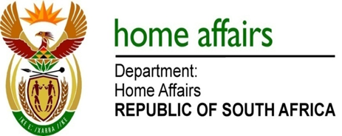

NATIONAL ASSEMBLY

QUESTION FOR WRITTEN REPLY

QUESTION NO. 3324

DATE OF PUBLICATION: Friday, 4 September 2015

INTERNAL QUESTION PAPER 36 OF 2015

3324. Ms H O Maxon (EFF) to ask the Minister of Home Affairs:

(1) (a)(i) What total amount did his department spend on his travel costs between Gauteng and Cape Town in the 2014-15 financial year and (ii) how many trips did he undertake between Cape Town and Gauteng in the specified financial year and (b) what total amount did his department spend on (i) hotel and (ii) residential or other accommodation for him in (aa) Cape Town and (bb) Pretoria in the 2014-15 financial year;
(2) (a)(i) what total amount did his department spend on the Deputy Minister’s travel costs between Gauteng and Cape Town in the 2014-15 financial year and (ii) how many trips between Gauteng and Cape Town did the Deputy Minister undertake in the specified financial year and (b) what total amount did his department spend on (i) hotel and (ii) residential or other accommodation for the Deputy Minister in (aa) Cape Town and (bb) Pretoria in the 2014-15 financial year? NW3901E
REPLY:

(1-2) The total amount used on travel by the department for Minister and Deputy Minister is made available on 2014/15 Annual Report tabled in Parliament in September 2015.

