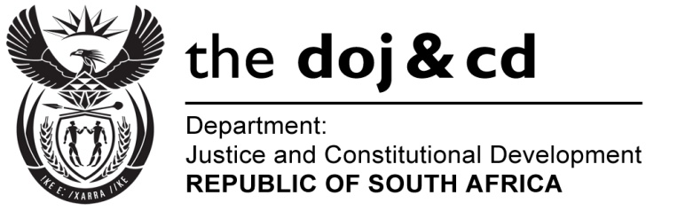

NATIONAL ASSEMBLY
QUESTION FOR WRITTEN REPLY
PARLIAMENTARY QUESTION NO.: 3184
DATE OF QUESTION: 28 AUGUST 2015
DATE OF REPLY: 11 SEPTEMBER 2015

Adv G Breytenbach (DA) to ask the Minister of Justice and Correctional Services:
Did he advise the President, Mr Jacob G Zuma, of the request of the former National Director of Public Prosecutions, Mr Mxolisi Nxasana, to have (a) Ms Nomgcobo Jiba and (b) Mr Lawrence Mwrebi suspended or removed from office? NW3782E

REPLY:
Yes.

