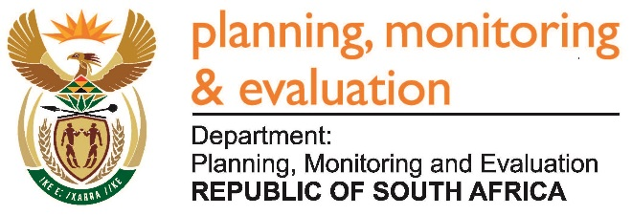 |  | 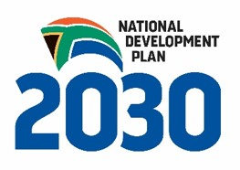
Private Bag X944, PRETORIA, 0001. Union Buildings East Wing, Government Avenue, PRETORIA
Tel: 012 312 0307. www.dpme.gov.za

317. Ms H Bucwa (DA) to ask the Minister in The Presidency:
(1) (a) What is the name of the company and/or companies appointed to provide services as outlined in The Presidency’s Evaluation of the Integrated Strategy for the Promotion of Entrepreneurship and Small Enterprises (RFP-16/2392), (b) on what date was the specified appointment made, (c) what is the budget allocated to the contract and (d) on what date is each of the specified service providers expected to deliver its report;
(2) will he make the specified report available to Ms H Bucwa; if not, why not; if so, by what date? NW336E
REPLY:

The name of the company is DNA Economics. It was appointed in November 2016. The budget allocation is R2 298 240, and the report is expected in November 2017. Once the report is approved by cabinet it becomes a public document that is published on the DPME website.

