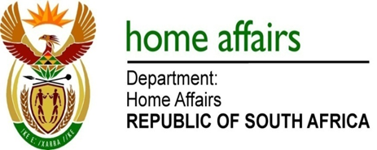

NATIONAL ASSEMBLY

QUESTION FOR WRITTEN REPLY

QUESTION NO. 308

DATE OF PUBLICATION: FRIDAY, 16 FEBRUARY 2018

INTERNAL QUESTION PAPER 2 OF 2018

308. Mr S Mokgalapa (DA) to ask the Minister of Home Affairs:

(a) What is the number of applications for (i) passports, (ii) identity documents, (iii) birth certificates, (iv) citizenship and (v) any other specified document that the staff of her department’s office in London processed in (aa) 2015, (bb) 2016 and (cc) 2017 and (b) what was the staff complement of the specified office in each of the specified years? NW330E
REPLY:

The information is tabulated as follows:

- Number of applications for |  | (aa) 2015 | (bb) 2016 | (cc) 2017
- Passports |  | 8546 | 9174 | 8756
- ID |  | 574 | 616 | 489
- Birth Certificate |  | 1671 | 2421 | 2331
- Citizenship |  | 3277 | 2371 | 1827
- Visas and permits |  | 7860 | 7715 | 7407
- Staff compliment | Locally recruited staff | 16 | 13 | 12
 | Transferred staff (DHA) | 4 | 4 | 4
 | Total | 20 | 17 | 16

