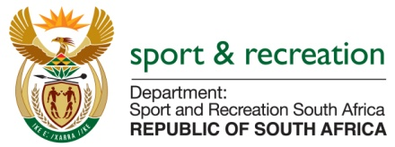

PARLIAMENTARY QUESTION FOR THE MINISTER

QUESTION 3074 (NW 3615E) FOR WRITTEN REPLY IN THE NATIONAL ASSEMBLY

QUESTION

Mr M S Malatsi (DA) to ask the Minister of Sport and Recreation:
(a) How does (i) his department and (ii) entities reporting to him define red tape and (b) what (i) specific interventions and /or (ii) systems have been implemented to (aa) identify and (bb) reduce red tape in (aaa) his department and (bbb) the entities reporting to him?

REPLY:
- (i) and (ii)
Complicated or unnecessary processes and procedures which impede or delay service delivery or decision making.
- Boxing South Africa (BSA) is currently reviewing its standard operating procedures.
South African Institute of Drug free Sport (SAIDS) is experience no red tapes.

