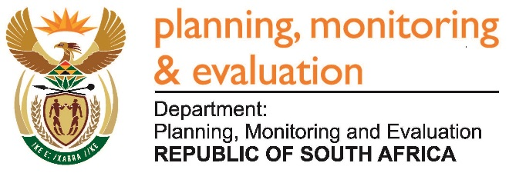 | 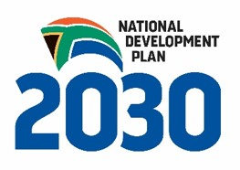
Private Bag X944, PRETORIA, 0001. Union Buildings East Wing, Government Avenue, PRETORIA
Tel: 012 312 0307. www.dpme.gov.za

____________________________________________________________________________________________
3010. Ms L V James (DA) to ask the Minister in the Presidency:
(1) What is the (a) total amount that was paid out in bonuses to employees in his Office and (b) detailed breakdown of the bonus that was paid out to each employee in each salary level in the 2016-17 financial year;
(2) what is the (a) total estimated amount that will be paid out in bonuses to employees in his Office and (b) detailed breakdown of the bonus that will be paid out to each employee in each salary level in the 2017-18 financial year? NW3329E
Reply:
During the 2016/17 financial year, four (4) employees received bonuses in the Ministry as follows:

Ministry
Salary Level | # of qualifying employees | Amount
Level 12 | 1 | R47 957.49
Level 13 | 1st official | R52 629.12
Level 13 | 2nd official | R54 418.06
Level 13 | 3rd official | R55 858.50
 | Total | R 210 863.17

The total amount paid during the 2016/17 financial year to other employees of DPME according to salary levels was as follows:

Salary Band | Qualifying employees | Amount
3 to 5 | 1 out of 15 | R 12 000.00
6 to 8 | 18 out of 52 | R 252 000.00
9 to 12 | 49 out of 119 | R1 656 000.00
Salary level 13 | 7 out of 41 | R 384 000.00
Salary level 14 | 1 out of 14 | R 64 000.00
Salary level 15 | 4 out of 14 | R 317 000.00
 | Total | R 2 685 000.00

The estimated amount to be paid to qualifying employees in the 2017/18 financial year is R2 015 417.00.

