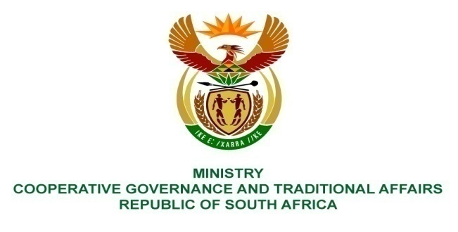
Private Bag x802, PRETORIA, 0001 Tel: (+27 12) 334 0705 Fax: (+27 12) 326 4478
Private Bag x9123, CAPE TOWN, 8000 Tel: (+27 21) 462 1441 Fax: (+27 21) 461 0851
________________________________________________________________________________________

FOR WRITTEN REPLY

NATIONAL ASSEMBLY

PARLIAMENTARY QUESTION NO 3000

Mr A M Matlhoko (EFF) to ask the Minister of Cooperative Governance and Traditional Affairs:
- Whether, with regard to the appointment of a certain company (name furnished) by the Ngaka Modiri Molema District
Municipality, the project management unit for which the specified company is hired is an internal municipality unit; if so, what are the relevant details;
- (a) for what project and (b) at what value was the specified company appointed?

REPLY
COGTA has engaged with the Ngaka Modiri Molema District Municipality (NMMDM) in order to obtain answers to these questions. The municipality has responded as follows:

- The Project Management Unit (PMU) is an internal unit of the municipality. It has been established under the Technical Services Section within the municipality, as provided for in the PMU Guidelines developed by the Department of Cooperative Governance.

The appointment of the company was prompted by a critical shortage of technical staff in the municipality. This included a shortage of planning, engineering and project management expertise. This had resulted in the municipality failing to spend its allocated MIG and other funds for projects within specified timeframes.

Currently, the company has suspended its support to the municipality due to non-payment of outstanding invoices by the municipality.

(2)(a) The company was appointed by the municipality for a period of three years with effect from 2 September 2013, ending on 31 August 2016, to provide technical support to the PMU unit. The company was appointed to carry out the following tasks as contained in the Terms of Reference (ToR) for the appointment:
• Provision of quality technical support and advice over the Project Life Cycle, which includes inception, planning, implementation, monitoring and reporting and close-out on the infrastructure programme in the municipality
• The development of contract briefs for submission to the Professional Service Providers appointed by the Ngaka Modiri Molema District Municipality (NMMDM).
• In respect of each project, scrutinize, approve and verify the accuracy and correctness of all practical and final completion certificates and recommend approval by the Senior Manager of the PMU
• Verification of all technical and financial aspects of the Infrastructure Programme
• Preparation of all required documentation for submission to the departments responsible for conditional grants and any other required reporting.

(2)(b)The contract amount over this period is R21,6 million from the municipality’s Equitable Share budget. Given that the NMMDM receives approximately R300 million per annum from the Municipal Infrastructure Grant (MIG), the municipality is within the 5% allowance for PMU costs in the MIG framework.

