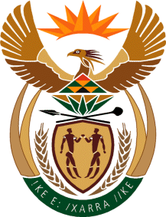

MINISTRY: COMMUNICATIONS
REPUBLIC OF SOUTH AFRICA
Private Bag X 745, Pretoria, 0001, Tel: +27 12 473 0164 Fax: +27 12 473 0585
Tshedimosetso House,1035 Francis Baard Street, Tshedimosetso House, Pretoria, 1000

NATIONAL ASSEMBLY
QUESTION FOR WRITTEN REPLY
QUESTION NUMBER: 2954 of 2015
DATE OF PUBLICATION: SEPTEMBER 2015
Mr G R Davis (DA) to ask the Minister of Communications:

With reference to her reply to question 453 on 27 November 2014, (a) when is the envisaged start and end date for the Information for Empowerment Dialogues, (b) which (i) stakeholders and (ii) towns and cities will be visited,(c) how many officials will participate and (d) what is the budgeted costs for the specified dialogues? NW3458E
REPLY: MINISTER OF COMMUNICATIONS
The Department could not source the funding for the Information and Empowerment Dialogues and these have been postponed indefinitely.

MR NN MUNZHELELE
DIRECTOR GENERAL [ACTING]
DEPARTMENT OF COMMUNICATIONS
DATE:

MS AF MUTHAMBI (MP)
MINISTER OF COMMUNICATIONS
DATE:

