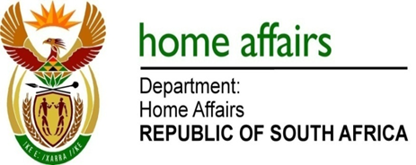

NATIONAL ASSEMBLY

QUESTION FOR WRITTEN REPLY

QUESTION NO. 2915

DATE OF PUBLICATION: FRIDAY, 6 OCTOBER 2017

INTERNAL QUESTION PAPER 34 OF 2017

2915. Ms N V Mente (EFF) to ask the Minister of Home Affairs:

Whether she has held a meeting with a certain family (name furnished); if not, why not; if so, (a) on what date was the meeting held, (b) where was the meeting and (c) what was the outcome of the meeting? NW3229E

REPLY:

The above forms part of a matter that is currently before the courts and is thus sub judice.

