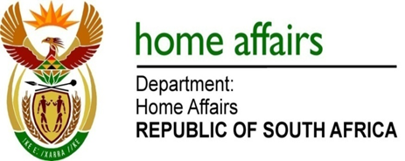

NATIONAL ASSEMBLY

QUESTION FOR WRITTEN REPLY

QUESTION NO. 2914

DATE OF PUBLICATION: FRIDAY, 6 OCTOBER 2017

INTERNAL QUESTION PAPER 34 OF 2017

2914. Ms H O Hlophe (EFF) to ask the Minister of Home Affairs:

Whether she intends to approve a payment of R300 million to a certain company (name furnished) that her department has accused of fraud; if not, why not; if so, what are the relevant details?
NW3228E

REPLY:

No, the matter is a subject of litigation in the courts.

