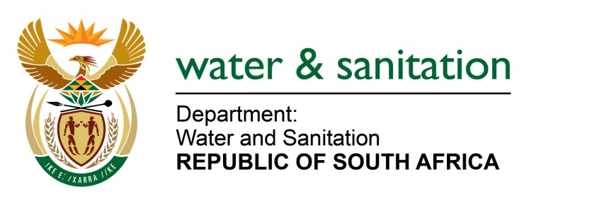

NATIONAL ASSEMBLY

FOR WRITTEN REPLY

QUESTION NO 281

DATE OF PUBLICATION IN INTERNAL QUESTION PAPER: 24 FEBRUARY 2017
(INTERNAL QUESTION PAPER NO. 4)

281. Mr L J Basson (DA) to ask the Minister of Water and Sanitation:
(1) Whether her department is currently experiencing any financial difficulties; if so, (a) when was the situation identified, (b) who identified the situation and (c) what steps are being taken to remedy the situation;
(2) what are the full relevant details of her department’s (a) current financial position and (b) balances of each bank account? NW299E
---00O00---
REPLY:
(1) My Department’s Main Account is not experiencing financial difficulties. However, the Water Trading Entity (WTE) is experiencing temporary cash flow problems due to non-payment of Municipalities and Water Boards. However, the WTE is in a very strong financial position as Assets exceed Liabilities by R72 billion.
During the 2016/17 budget preparation it was clear that, should the debt not be recovered this would negatively impact on the bank balance. This recovery from Municipalities and Water Boards has not happened and the overdraft has been steadily increasing since the start of the financial year.
The WTE is working closely with National Treasury (NT) and NT has sent out letters to Municipalities not paying their debt warning them that they are contravening Section 65(2)(e) of the MFMA and that they should urgently rectify the non-payment of their debt.
(2) My Department’s Main Account has been allocated a budget of R15.5 billion for the 2016/17 financial year, of which R13.6 billion has been spent by 27 February 2017, leaving an available balance of R1.9 billion up to 31 March 2017. The R1.9 billion will be used to pay for salaries (R238 million), direct transfers to Municipalities scheduled for the 8 and 9 March 2017 (R712 million) as well as goods and services and capital expenditures in the normal course of business amounting to R958 million. This is in line with my Department’s planned cash projections, and signals a slight underspending of R99 million anticipated by the end of the financial year from Compensation of Employees.

The Department’s bank account with National Treasury (SARB) is currently at a positive balance of R558 million, and there is still a balance of R1.1 billion which has not been requested from the National Treasury and is due for payment to the Department in the month of March 2017.

The WTE’s current bank balances as at 22 February 2017 are as follows:

Reserve Bank | (R 2 989 564 608.84)
ABSA | R 24 872536.05
Standard Bank | R 1 735 342.16
First National Bank | R 420 719.30
SAPO | R 96 644.15
Total | (R 2,962,439,367.18)

---00O00---

