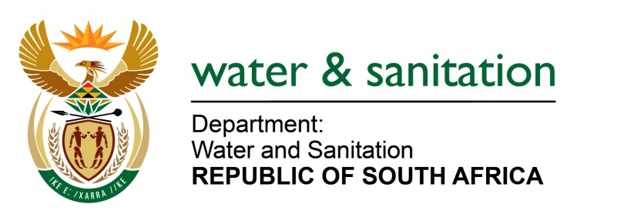

NATIONAL ASSEMBLY

FOR WRITTEN REPLY

QUESTION NO 280

DATE OF PUBLICATION IN INTERNAL QUESTION PAPER: 24 FEBRUARY 2017
(INTERNAL QUESTION PAPER NO. 4)

280. Mr L J Basson (DA) to ask the Minister of Water and Sanitation:
(a) How many supplier invoices currently remain unpaid by her department for more than 30 days and (b) what (i) is the name of the company and/or supplier, (ii) amounts are outstanding, (iii) is the reason for nonpayment and (iv) is the envisaged date on which the amounts will be paid? NW298E
---00O00---
REPLY:
- The total amount of unpaid invoices is R 677 million. Refer to Annexure A for the details.
(b) Refer to Annexure A for the name of company and/or supplier and outstanding amounts. Below are reasons for the non-payments.
Description | Reasons for the non-payment
Giyani Water Services Invoices | The Giyani invoices of R202 million are being disputed by the Department as they are above the signed contract value, and no authorization was provided by the Department for the service provider to exceed the contract amount.
Drought Interventions Invoices | The Drought Interventions invoices were delayed due to the budget reallocation process within the Department to make funds available as National Treasury only made available R290 million for the Desalination Plant and R50 million for water tankers. All other drought interventions were not funded. The Department has however made funds available to pay the R475 million for drought interventions in the current financial year.
Bucket Eradication Invoices | The Bucket Eradication invoices were delayed due to unavailability of funds within the Bucket Eradication Program. The Department has however reprioritized its budget to pay current invoices on hand, however additional funds are required to complete the Bucket Eradication Program.

---00O00---

