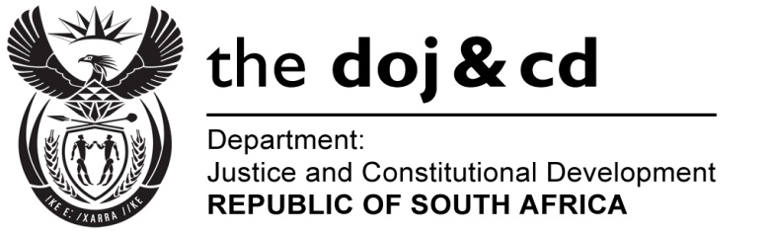
Private Bag X276, Pretoria, 0001, Tel (012) 406 4669, Fax (012) 406 4680
Private Bag X256, Cape Town, 8000, Tel (021) 467 1700 Fax (021) 467 1730
NATIONAL ASSEMBLY
FOR WRITTEN REPLY
QUESTION 2719
DATE OF PUBLICATION OF INTERNAL QUESTION PAPER: 07/12/2016

(INTERNAL QUESTION PAPER 43 OF 2016)

DATE OF SUBMISSION: 22 DECEMBER 2016
Adv A de W Alberts (FF Plus) to ask the Minister of Justice and Correctional Services: †
- Whether, in light of the fact that South Africa has signed and ratified the International Convention/Treaty on Civic and Political Rights, including the optional protocol which allows for individual complaints, the Government intends creating legislation for making the rights contained in the Treaty applicable locally; if not, why not, given the Government’s international and constitutional obligations in this regard; if so, (a) by what date and (b) what are the further relevant particulars regarding the process and proposed content;
- how many of all the international human rights instruments have been signed and ratified by South Africa;
- in cases where there was no signing or ratification of a convention/treaty, what was the reason for that, seen against the background of the Government’s constitutional obligations regarding human rights;
- whether there are any plans for signing or ratifying the convention/treaty;
- (a) what are the compulsory dates for handing in the reports, (b) on what dates has the Government actually submitted reports since the signing and ratification of each international human rights instrument, (c) what are the reasons for any default regarding the submission or late submission of the reports in each separate case and (d) whether each of the reports is available?
NW3171E
REPLY:

- (a) South Africa has ratified the International Covenant on Civil and Political rights
(ICCPR) which required domestication through national legislation as per section 231(4) of the Constitution. There is no additional legislation required to implement the tenets of the ICCPR because South Africa has not only enshrined civil and political rights within the Bill of Rights in the Constitution of the Republic of South Africa (Act 108 of 1996), but South Africa also has existing legislative and policy frameworks in place to give effect to civil and political rights.
(b) South Africa has ratified the OP-ICCPR and is yet to domesticate same through
The enactment of national legislation. Same is receiving attention.

- A total of nine (9) Human Rights conventions have been signed and ratified by South Africa.
Overall, South Africa is party to (has ratified) thirty-two (32) international treaties/ conventions. These relate to international human rights; humanitarian law, labour, environmental law, maritime law, labour law, trade, education, conservation and anti-corruption.
- The decision to become party to an international instrument is taken with due regard of government’s priorities (at a given time). As these are constantly changing and being revised in light of the most pressing needs, so also does the ratification of international instruments need to change to reflect the change in societal needs and development.
- Same is receiving attention, and is under due consideration by Government.
- The list of all treaty obligations and reporting status is attached.
With regard to the Department of Justice and Constitutional Development’s mandate on international obligations, the following should be noted:
- Each treaty has different periodic reporting requirements- some are quadrennial, while other are biennial and the Human Rights Bodies which consider the reports may request further information or may make recommendations on when the country should deposit its next report.
- South Africa deposited the 1st-3rd combined periodic reports on the ICERD in 2006, and the 4th-8th combined periodic reports in 2012; the 1st ICCPR report was submitted in 2014; the 1st periodic report on the CAT was submitted in 2005 and the 2nd and 3rd reports were submitted in 2015. The 1st periodic report on the ACHPR was submitted in 1999, the 3rd-6th combined periodic reports were submitted in 2005, the 1st and 2nd UPR reports were submitted in 2008 and 2012 respectively and the 3rd UPR report is due in May 2017 and the 1st periodic report on the ICESCR is due in May 2018.
- Challenges with capacity and lengthy consultative processes.
- Yes, each of the reports is available.

