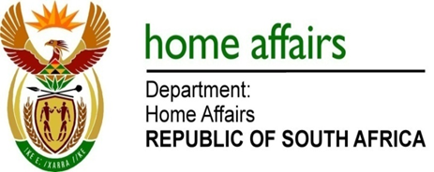

NATIONAL ASSEMBLY

QUESTION FOR WRITTEN REPLY

QUESTION NO. 269

DATE OF PUBLICATION: Friday, 24 February 2017

INTERNAL QUESTION PAPER 4 OF 2017

269. Mr M H Hoosen (DA) to ask the Minister of Home Affairs:

- How many Syrian Arab Republic nationals have (a) applied for asylum, (b) been granted refugee status and (c) been denied (i) asylum and (ii) refugee status in each of the past 10 calendar years;

(2) has his department placed any limits on the number of asylum and refugee status applications it will receive from nationals from the Syrian Arab Republic; if so, what are the relevant details? NW287E
REPLY:

- The information is in the table below:

SYRIAN ARAB REPUBLIC NATIONALS
YEAR | - APPLIED FOR ASYLUM | - GRANTED  REFUGEE STATUS | (c) DENIED REFUGEE STATUS
2007 | 0 | 0 | 0
2008 | 1 | Information not available | Information not available
2009 | 0 | 0 | 0
2010 | 0 | 0 | 0
2011 | 0 | 0 | 0
2012 | 5 | 2 | 0
2013 | 11 | 6 | 3
2014 | 40 | 11 | Information not available
2015 | 27 | 3 | 7
2016 | 20 | 12 | 12

- No

