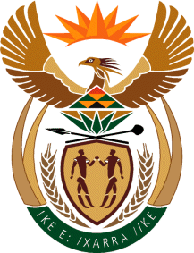
MINISTRY: SPORT AND RECREATION
REPUBLIC OF SOUTH AFRICA

Private Bag X869, Pretoria, 0001, Tel: (012) 304 5158, Fax: (012) 323 8426
Private Bag X9149, Cape Town, 8000, Tel: (021) 465 5506/7/8/9, Fax: (021) 465 4402

Parliamentary Question to the Minister

2682. Mr D Bergman (DA) to ask the Minister of Sport and Recreation:
(a) On which date were the promoters of the SA Broadcasting Corporation boxing bout informed that the event would be cancelled which was to have taken place on 24 November 2016 in Kimberley in the Northern Cape, (b) what was the reason for the cancellation of the specified event, (c) what amount was lost due to the cancellation of the event and (d) who paid for the lost funds? NW3173E
Reply

We are still trying to source in the archives; the information required is not readily available

