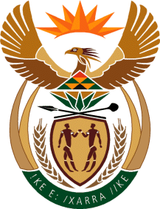

MINISTRY: COMMUNICATIONS
REPUBLIC OF SOUTH AFRICA
Private Bag X 745, Pretoria, 0001, Tel: +27 12 473 0164 Fax: +27 12 473 0585
Tshedimosetso House,1035 Francis Baard Street, Tshedimosetso House, Pretoria, 1000

NATIONAL ASSEMBLY
QUESTION FOR WRITTEN REPLY
QUESTION NUMBER: 2664
DATE OF PUBLICATION: 25 NOVEMBER 2016

Ms P T van Damme (DA) to ask the Minister of Communications:
With reference to remarks made by the Group Chief Executive of Corporate Affairs of the SA Broadcasting Corporation, Mr Hlaudi Motsoeneng, at The New Age Business Briefing on 27 October 2016, that he allegedly met a certain person (name furnished) at an unknown hotel, (a) what are the names of each person who attended the specified meeting, (b)(i) on what date and (ii) where did the meeting take place, (c) what was the purpose of the meeting and (d) what were the decisions at the meeting? NW3148E
REPLY: MINISTER OF COMMUNICATIONS

This matter is a subject of an on-going legal case and therefore sub-judice. Thus, the SABC cannot at this stage respond to the question.

MR NN MUNZHELELE
DIRECTOR GENERAL [ACTING]
DEPARTMENT OF COMMUNICATIONS
DATE:

MS AF MUTHAMBI (MP)
MINISTER OF COMMUNICATIONS
DATE

