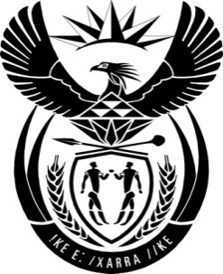

THE PRESIDENCY: REPUBLIC OF SOUTH AFRICA
Private Bag X1000, Pretoria, 0001
NATIONAL ASSEMBLY
QUESTIONS FOR WRITTEN REPLY

QUESTION NO: 2634
Date Published: 25 November 2016

Ms D Carter (Cope) to ask the President of the Republic:
Whether, with reference to reported allegations (details furnished), he is aware of any bribe money paid by the Russians in relation to the procurement of nuclear generating capacity for the Republic of South Africa? NW3115E

Reply
The Procurement of the Nuclear New Build Programme (NNBP) has not yet started and the Request for Proposals has yet not been issued. Various organs of state involved in the Programme are currently doing preparatory work related to the procurement process, including the development of a governance and management framework for the Programme with the different roles and responsibilities being articulated.

Government is not aware of any bribe and/or money that has been paid by any prospective bidder(s) for the Nuclear New Build Programme. Government is committed to a fair and transparent procurement process for the NNBP and will act against anyone who compromises the integrity of the process by acting unlawfully or improperly. The Nuclear New Build Programme is central to the country’s long term energy plans in order to reduce greenhouse emissions, ensure security of electricity, and contribute to economic development and job creation.

