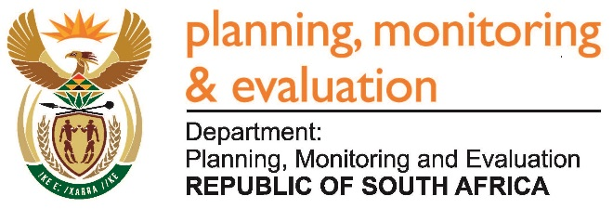 | 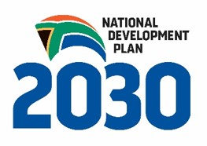
Private Bag X944, PRETORIA, 0001. Union Buildings East Wing, Government Avenue, PRETORIA
Tel: 012 312 0307. www.dpme.gov.za

____________________________________________________________________________________________
2596. Mr J R B Lorimer (DA) to ask the Minister in The Presidency:
(1) (a) What were the detailed outcomes of the discussions on Mining Operation Phakisa held in 2015, (b) how long did the specified discussions take, (c) where were the discussions held, (d) who attended the discussions and (e) what amount did the hosting of discussions cost;
(2) whether the specified outcomes were published in a report; if not, why not; if so, on what date was the specified report published;
(3) will he furnish Mr J R B Lorimer with a copy of the specified report? NW3009E
Reply:
The intended outcomes of the initiatives include;
- Promoting investment in the mining cluster in the newly established One-Stop-Shop facility that links to the Invest South Africa process, developing a common message across key stakeholders and unlocking impediments to the entry of independent black capital.
- Increasing exploration through the provision of cutting edge geo-scientific information and special funding mechanisms.
- Increasing participation of emerging miners in the mining value chain by creating alternative funding mechanism and creating mechanisms for collaboration with Majors.
- The implementation of an industry wide decent work program with an initial focus on rights at work, the rejuvenation of Future Forums, policy alignment and social protection.
- The implementation of a cluster reskilling and upskilling programme that is collaborative, transparent and enables mobility across the cluster.
- The establishment of a multi-stakeholder crisis intervention task force (modelled on government intervention post the financial crisis) with the objective of saving marginal mines and jobs.
The Mining Phakisa Lab took five weeks, from 26 October 2015 to the 27 November 2015 in Limpopo (3 weeks at the Legends Resort) and at the Capital Hotel in Sandton (2 weeks).
Stakeholders from organised business, organised labour, civil society, some chapter 9 institutions, Congress of traditional Leaders and government departments attended the Mining Phakisa lab. The cost was R26 785 520.81 and the report will be made available after the Presidential Launch in December 2016.

