PARLIAMENT OF THE REPUBLIC OF SOUTH AFRICA
NATIONAL ASSEMBLY

QUESTION FOR WRITTEN REPLY
PARLIAMENTARY QUESTION: NO. 2559
DATE OF QUESTION: 18 NOVEMBER 2016
DATE OF SUBMISSION: 02 DECEMBER 2016

Ms M C C Pilane-Majake (ANC) to ask the Minister of Justice and Correctional Services:
In light of the fact that the Justice, Crime Prevention and Security Cluster’s efforts to reduce the number of remand detainees in correctional services, estimated to be 40 000, which have not managed to yield the desired results, what additional measures is he, as the Executive responsible for three of the Budget Votes that directly impact on this desired outcome, recommending to deal with overcrowding in correctional centres that is too costly for the country? NW2882E
REPLY:

There has over the years been a significant reduction in the number of remand detainees.

Periods | Average number of RDs
Average March 2012 | 47191
Average Sept 2012 | 45138
Average March 2013 | 46852
Average Sept 2013 | 43360
Average March 2014 | 43973
Average Sept 2014 | 40146
Average March 2015 | 42901
Average Sept 2015 | 40675
Average March 2016 | 44026
Average Sept 2016 | 41486
Reduction in numbers | 5705
Reduction in % | 12.09%

The table above reflecting the trends from March 2012 to September 2016 revealed that the population of RDs reduced by 12.09% over a period of five years. This reduction should be equated to the team effort of various role players who contribute in the implementation of the strategies. These results could be much better if the factors that play a role in delaying cases could be effectively managed. A further study is required with focus on the remand detainees with co-accused whose cases take longer than three years. Another area that requires attention is the front end of the Criminal Justice System with focus on the RDs that spend up to three months in detention.

Children Remand Detainees:
With the introduction of the Child Justice Act (Act 75 of 2008), the number of RD children reduced from 504 in March 2010 to an annual average of 99 in 2015/16. The lowest average number of children was recorded in August 2016 (72). The overall reduction of children RDs from 2010 to August 2016 was 85.7%.

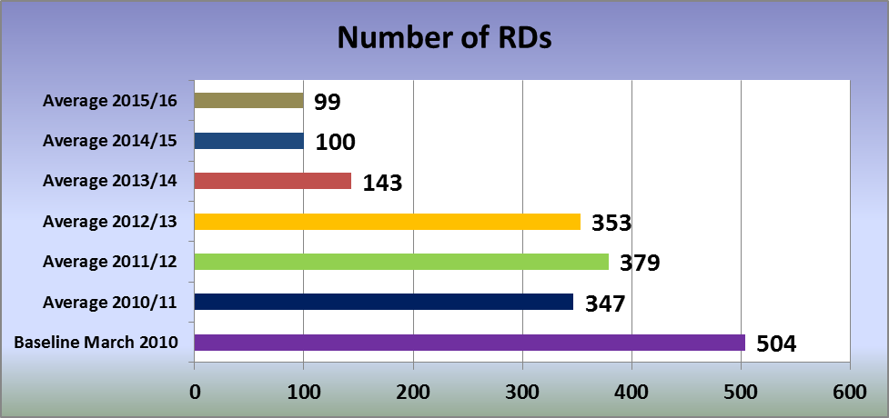

It is crucial to understand that the key drivers of the population of the remand detainees are beyond the control of the detention institutions. These drivers, according to international literature, are the use of pre-trial detention and the increasing trend in serious crimes. The increase in serious crimes is closely related to an increase in the use of pre-trial detention by courts without the option of bail.

The number of admissions and the length of stay are regarded as other drivers which are beyond the control of institutions responsible for the detention of RDs. Factors found to be linked to the increase in the length of stay of remand detainees are as follows,
- The presence of multiple co-accused in one case or accused linked to other crimes that are under investigation;
- Withdrawal, rehiring of legal representatives and changing of legal representatives by the accused;
- Failure of the co-accused and or their legal representative to appear in court on set dates thus leading to remanding of the cases for several times;
- Request for the separation of trials by the accused in the middle of the cases;
- Brings of bail applications by the accused in the middle of the trail through the bail application was attended to at the beginning of the case;
- Delays in securing a date at the high court for the cases that are escalated by lower courts to high courts;
- Loss of court records;
- Failure of witnesses to appear in court;
- Presence of multiple witnesses in some cases;
- Requests for remand either by defence, lawyers of the accused and/or the state;
- Failure of the co-accused to appear in court especially those that are under non-custodial system;

In addition to the previously mentioned key drivers, there are other factors that are thought to play a role in the failure to reduce the number of RD’s. These factors include failure to pay bail by the remand detainees who have been given bail by courts. The percentage of such RD’s ranges between 15 and 19%.

Despite all the challenges mentioned above there are several strategies implemented to deal with overcrowding at the cluster level and the departmental level.

Additional interventions which specifically focus on the down management of remand detainees by the DCS are:

- The implementation of bail protocol (Section 63A of Criminal Procedure Act, Act 51 of 1977). The protocol makes provision for the Head of a Correctional Centre to approach the relevant court to release an accused on warning in lieu of bail or to amend the bail conditions imposed by that court when the offender population of a particular correctional centre is reaching such proportions that it constitutes a material and imminent threat to human dignity, physical health or safety of the accused. It is worth mentioning that this section is only applicable to those accused with bail who have been charged with Schedule 7 crimes.

- The Marketing of section 63(1) of the Criminal Procedure Act (Act 51 of 1977). Section 63(1) makes provision for the accused or prosecutor to make an application to the court to reduce the amount of bail that was set by the relevant court.

- Referral of RDs to court for consideration of their length of detention. The Correctional Service Act (section 49G) makes provision for the Head of the Centre to submit an application to court for the consideration of the length of detention of the RDs before they complete two years in detention initially (application submitted at 21 months) and annually with regard to subsequent applications. The provision does not suggest that there is custody limit in terms of period of detention in South Africa for RDs. The courts responds by utilizing the provisions applicable to section 63A applications as there is no parallel provision in the Criminal Procedure Act.

The cluster approach in the reduction management of remand detainees appears to be effective. The DCS alone could not be successful in reducing the population of the RDs. The Executive Head of the Department of Justice and Correctional Services in consultation with Director of NPA and the National Commissioner of Correctional Services has appointed a bail task team which has been assigned to determine factors that contribute to the RDs staying in detention while they have an option of paying bail. The task team falling under the Criminal Justice System Reform is finalizing the report on audit conducted in Pollsmoor and the Mthatha centres remand detention facilities. It is hoped that the report will assist in providing guidance on coming up with alternative approaches for managing RDs with bail.

