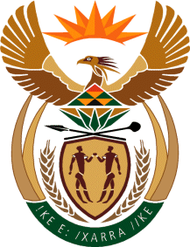

MINISTRY: COMMUNICATIONS
REPUBLIC OF SOUTH AFRICA
Private Bag X 745, Pretoria, 0001, Tel: +27 12 473 0164 Fax: +27 12 473 0585
Tshedimosetso House,1035 Francis Baard Street, Tshedimosetso House, Pretoria, 1000

NATIONAL ASSEMBLY
QUESTION FOR WRITTEN REPLY
QUESTION NUMBER: 2539
DATE OF PUBLICATION: 11 NOVEMBER 2016

Ms V van Dyk (DA) to ask the Minister of Communications:
What (a) was the purpose of her attendance at the NexTV CEO Africa 2016 Summit in Mauritius on 29 and 30 September 2016, (b) are the (i) names and (ii) positions of persons who accompanied her and (c) was the (i) total cost and (ii) detailed breakdown of such costs of the specified trip? NW2953E
REPLY: MINISTER OF COMMUNICATIONS
- NexTV CEO Africa 2016, was an exclusive event that brought together the Anglophone and Francophone markets of Sub Saharan Africa to discuss strategic ventures, regulatory issues and will be a fantastic accelerator for business and for lobby in the broadcasting industry going forward. Minister Faith Muthambi was invited to participate and give a keynote address at the opening session of the two-day summit, where she addressed delegates on the digital television revolution in Africa.
- (i) & (ii)
- Ms Basani Baloyi: Chief of Staff;
- Mr Sandile Nene: Special Advisor to the Minister; and
- Mr Nthambeleni Gabara: Assistant Director: GCIS SANews Unit.
- (i) R 184 420.44
(ii) Accommodation: R44 949.50
Flights: R 121 459.66
Travel allowance: R18 011.28

MR NN MUNZHELELE
DIRECTOR GENERAL [ACTING]
DEPARTMENT OF COMMUNICATIONS
DATE:

MS AF MUTHAMBI (MP)
MINISTER OF COMMUNICATIONS
DATE

