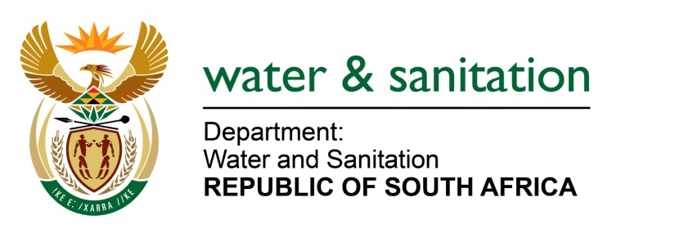

NATIONAL ASSEMBLY

FOR WRITTEN REPLY

QUESTION NO 2352

DATE OF PUBLICATION IN INTERNAL QUESTION PAPER: 14 AUGUST 2017
(INTERNAL QUESTION PAPER NO. 26)
2352. Mr L J Basson (DA) to ask the Minister of Water and Sanitation:
(1) (a) For how long has the position of the Chief Executive Officer (CEO) at the Overberg Water been vacant (b) why has this vacancy not been filled;
(2) Whether the current acting CEO was ever recommended for permanent appointment in this position; if so, (a) on what date was the recommendation first made and (b) why has no action been taken in this regard? NW2597E

---00O00---
REPLY:
(1)(a) The position of the Chief Executive Officer (CEO) of Overberg Water has been vacant since May 2015 to date.
(1)(b) My Department seconded Ms ONV Fundakubi as the acting CEO at Overberg Water. The secondment was effective from 1 July 2015 and terminated on
22 June 2017.
(2) Yes, the current acting CEO, Mr Phakamani Buthelezi, was recommended by the selection panel for permanent appointment as CEO at Overberg Water.
(2)(a) On 9 March 2016, the panel recommended to the Overberg Water Board the approval of the appointment of Mr Buthelezi for the position of CEO at Overberg Water.
(2)(b) My Department wanted the Board and former Acting CEO, Ms Fundakubi to deal with all outstanding issues related to the finalisation of the Annual Report of 2016/17 before processing the appointment of the new CEO.
---00O00---

