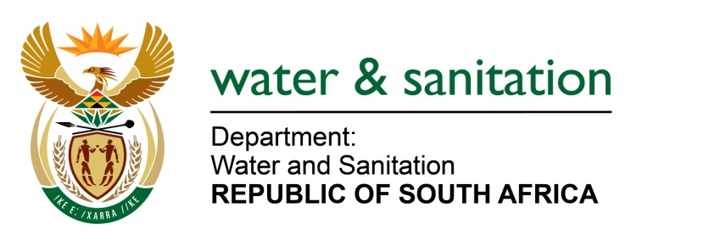

NATIONAL ASSEMBLY

FOR WRITTEN REPLY

QUESTION NO 2348

DATE OF PUBLICATION IN INTERNAL QUESTION PAPER: 14 AUGUST 2017
(INTERNAL QUESTION PAPER NO. 26)
2348. Ms T E Baker (DA) to ask the Minister of Water and Sanitation:
Whether Magalies Water is paying for any courses or further studies of its (a) Chief Operating Officer and/or (b) Chief Executive Officer; if so, in each case, (i) what are the relevant details, (ii) at which institutions, (iii) what are the costs of the courses and/or studies and (iv) for what period of time? NW2593E
---00O00---
REPLY:
Yes, Magalies Water is paying for courses or further studies for the Chief Operating Officer and the Chief Executive Officer for a Senior Executive Program-Africa: Harvard Business School in collaboration with Gordon Institute of Business Science. The total cost of the courses is R326 542.50 each (US$25,000/person) for the period 31/07/2017 to 01/12/2017. Below are further details regarding the courses as follows:
The Senior Executive Program-Africa is aimed at building exceptional leaders in the African continent. Harvard Business School Executive Education offers the Senior Executive Program - Africa, in partnership with the Gordon Institute of Business Science (GIBS) of Pretoria University in South Africa. It is designed to strengthen the leadership skills and build insight into local, regional, and global markets, the program explores the proven approaches of successful leaders in Africa and around the globe, preparing participants to compete effectively, seize the region's many growth opportunities, and sustain success for one’sorganisation.
The 2017 offering comprises a module in Kigali from 13 August to 18 August 2017; an independent work module from August 2017 to November 2017; and a module on the Harvard Business School campus in Boston from 26 November to 01 December 2017. It is intended to help participants build the knowledge, perspective, and confidence needed to lead more effectively and accelerate the company's growth. Participants also have the opportunity to share insights and learn from other senior leaders across Africa.
---00O00---

