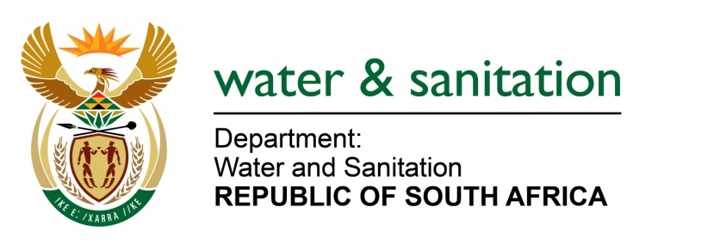

NATIONAL ASSEMBLY

FOR WRITTEN REPLY

QUESTION NO 2304

DATE OF PUBLICATION IN INTERNAL QUESTION PAPER: 14 AUGUST 2017
(INTERNAL QUESTION PAPER NO. 26)
2304. Ms M S Khawula (EFF) to ask the Minister of Water and Sanitation:
Other than the recognition of the importance and value of South Africa’s strategic water source areas in the National Water Resources Strategy 2, what is her department doing to ensure that the water source areas are given effective legal protection through the National Water Act, Act 36 of 1998? NW2543E
---00O00---
REPLY:

Chapter 3 of the National Water Act, 1998 makes provision for the protection of water resources. As part of protecting the water resources, the Minister is required to determine water resource classes and Resource Quality Objectives. The water source areas will therefore be protected by ensuring that they are prioritized for protection when determining the water resource classes and resource quality objectives. Once the class of a water resource and the resource quality objectives have been determined they are binding on all authorities and institutions when exercising any power or performing any duty under the National Water Act, 1998. The Department has regulatory measures in place, which include monthly water quality monitoring programmes in order to ensure that the levels of protection are maintained and any transgressors are dealt with accordingly.

---00O00---

