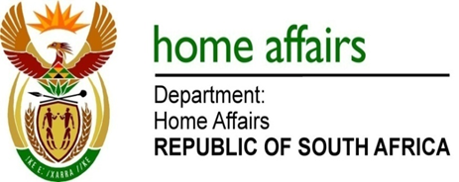

NATIONAL ASSEMBLY

QUESTION FOR WRITTEN REPLY

QUESTION NO. 225

DATE OF PUBLICATION: Friday, 19 February 2016

INTERNAL QUESTION PAPER 2 OF 2016

225. Ms E N Louw (EFF) to ask the Minister of Home Affairs:

Has his department awarded any contracts to companies indirectly or directly owned by certain persons (names furnished) in the (a) 2012-13, (b) 2013-14 and (c) 2014-15 financial years; if so, in each specified financial year, (i) how many times were such contracts awarded and (ii) for what amount? NW226E
REPLY:

(a-c) The department has not awarded any contracts indirectly or directly to companies owned by certain persons in the 2012-13, 2013-14 and 2014-15 financial years.

(i-ii) Falls away

