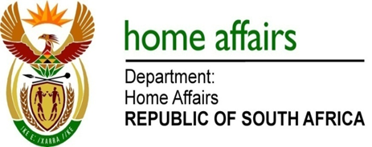

NATIONAL ASSEMBLY

QUESTION FOR WRITTEN REPLY

QUESTION NO. 2140

DATE OF PUBLICATION: Friday, 14 October 2016

INTERNAL QUESTION PAPER 30 OF 2016

2140. Mr D W Macpherson (DA) to ask the Minister of Home Affairs:

Whether certain Russian nationals (names furnished) entered the Republic (a) in the (i) 2011-12, (ii) 2012-13, (iii) 2013-14, (iv) 2014-15 and (v) 2015-16 financial years and (b) since 1 April 2016; if so, (aa) what was the nature of each of the specified persons’ visit and (bb) how long did each visit last? NW2458E
REPLY:

Due to insufficient information provided regarding the referred nationals above, I am unable to determine with complete accuracy the movement of such persons. Details such as passport numbers and related information will be crucial to determine if these individuals entered the Republic and the nature of their visits.

