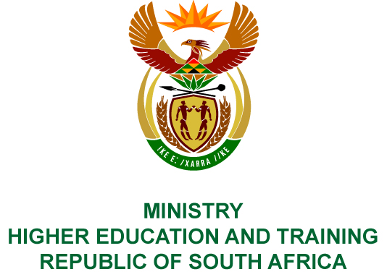
Private Bag X893, Pretoria, 0001, Tel (012) 312 5555, Fax (012) 323 5618
Private Bag X9192, Cape Town, 8000, Tel (021) 469 5150, Fax: (021) 465 7956
Memorandum from the Parliamentary Office
NATIONAL ASSEMBLY
FOR WRITTEN REPLY
QUESTION 2118
DATE OF PUBLICATION OF INTERNAL QUESTION PAPER: 23/09/2016

(INTERNAL QUESTION PAPER 29 OF 2016)

Mr M S Mbatha (EFF) to ask the Minister of Higher Education and Training:

(a) How is the role of the National Institute for the Humanities and Social Services different from that of the (i) Council for Higher Education, (ii) Academy of Science of South Africa, (iii) Universities South Africa, (iv) Human Sciences Research Council and (v) National Research Foundation and other institutions which advance research, teaching and learning and (b) what process was followed with regard to the allocation of funds to (i) catalytic projects, (ii) humanities hubs and (iii) BRICS collaborations?

NW2430E

REPLY:
- The National Institute for the Humanities and Social Services (NIHSS) is a complementary institute to existing institutions but focuses specifically on advancing and strengthening Human and Social Science disciplines in South African universities. This includes assisting universities to realise their potential contribution to the ongoing project of post-colonial and post-apartheid nation-building, national development, the building of a democratic culture and the development of a strong tradition of progressive, empirical and theoretical research. The NIHSS seeks to build relationships with academics in South Africa, Africa and BRICS. Some of the areas of research of the NIHSS may coincide with the interests of other statutory institutions. Practically, the principle of complementarity requires ongoing sustained and regular consultation and cooperation with these institutions. Taking into consideration the mandates, roles and functions of stakeholders such as the Council on Higher Education, Academy of Science of South Africa, Universities South Africa (USAf), Human Sciences Research Council and National Research Foundation, it is the Department’s view that our higher education and research system needs diversity based on a differentiation of visions, focuses and priorities.
USAf is a body that has been established by university management representing South African Universities. Its mandate amongst others is to influence and contribute to policy positions regarding higher education. USAf itself does not conduct research but delegates this function to various stakeholders within the system.
- (i) For the 2015/16 financial year, the NIHSS issued a call for Catalytic Research Project proposals on 19 November 2015, with a submission deadline of 18 December 2015. The call was advertised in the Mail & Guardian and on the NIHSS website. Notification was sent to the South African Humanities Deans' Association (SAHUDA) to disseminate to participating institutions. Fifty-three research grant proposals were received from academics in South African higher education institutions. Proposals were internally screened for project and administrative compliance. Internal and external committees reviewed the research proposals against set criteria. The Academic Committee of the Board also reviewed all research proposals.

The outcomes of the review processes were as follows:
- 8 proposals were awarded full funding under the Catalytic Research Programme;
- 10 proposals that showed some potential for becoming catalytic were recommended for seed funding;
- 5 of the successful proposals were considered to be Working Groups and will be funded under the Working Groups for Academic Collaboration programme;
- 9 proposals showed some potential but required further discussions and approval; and
- 21 proposals were not approved for funding.
(ii) Liliesleaf Farm Pilot Humanities Hub was identified in 2014, as part of the Ministerial Special Project phase of the Institute. A closed call for proposals for new Humanities Hubs will be issued in the 2016/17 financial year to heritage sites in South Africa or similar sites. All proposals will be reviewed internally and externally by independent experts in the field.
(iii) All BRICS related collaborations with member countries are discussed at the BRICS Think Tank Council meetings. Research projects funded by the NIHSS in the various BRICS countries are done through an open call and in partnership with similar organisations in the respective BRICS countries.
For the 2015/16 financial year, the NIHSS and Indian Council of Social Science Research (ICSSR) issued a joint call for research proposals between South African and Indian researchers in Social Sciences and Humanities. The call for research proposals was advertised on the NIHSS website and sent to universities (Deans Association). The advertisement closed on 15 June 2015 and 16 applications were received in South Africa and 14 in India. The applications were screened for administrative, project compliance and prepared for review. The NIHSS-ICSSR Joint Advisory Committee (JAC) meeting was held on 3 November 2015 in Cape Town, South Africa. The NIHSS/ICSSR Joint Research Programme approved 13 projects of which 11 are fully funded projects and 2 will receive seed funding. Five ICSSR applications were approved for funding.
The NIHSS has also been working closely with the Human Sciences Research Council (HSRC) to establish the South African BRICS Think Tank.
COMPILER/CONTACT PERSONS: Ms P Whittle and Dr D Parker
EXT: 5248/6214

DIRECTOR – GENERAL
STATUS:
DATE:

QUESTION 2118 APPROVED/NOT APPROVED/AMENDED

Dr BE NZIMANDE, MP
MINISTER OF HIGHER EDUCATION AND TRAINING
STATUS:
DATE:

