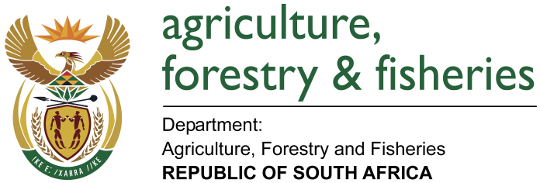
NATIONAL ASSEMBLY

WRITTEN REPLY

QUESTION 2104 / NW 2333E

MINISTER OF AGRICULTURE, FORESTRY AND FISHERIES:
Mr M M Dlamini (EFF) to ask the Minister of Agriculture, Forestry and Fisheries:

QUESTION:
Why has South Africa not signed and ratified the International Treaty on Plant Genetic Resources for Food and Agriculture? NW2333E
REPLY:

South Africa has been a keen participant in the process leading up to the adoption of the International Treaty on Plant Genetic Resources for Food and Agriculture. Over the years the department has been keeping an eye on whether the ideals of the Treaty have been attained. It has been the view of the department that the implementation of the Treaty has suffered as a result of financial constraints and the capacity of Contracting Parties to fulfil all obligations under the Treaty, especially those from developing countries. Considering the 2017 Report of the Compliance Committee, established in line with Articles 19.3e and 21 of the Treaty, tensions are already evident between provider Countries (which are mostly developing countries) and accessing Countries (majority being developed countries). Developing Countries maintains a view that they’ve seen little financial benefits resulting from the operation of the Multilateral System of Access and Benefit-sharing established in terms of Articles 10 to 13 of the Treaty.

This, however, does not mean that the department is not doing anything in addressing the objectives of the Treaty. Most of the activities of the Treaty already form part of the core functions of the National Plant Genetic Resources Centre as part of the National Programme on Conservation and Sustainable Use of Plant Genetic Resources for Food and Agriculture. The Programme focuses on the collection, characterisation and storage of plant genetic resources for food & agriculture complemented by on-farm conservation of these resources as well as the establishment of Community Seed-Banks, of which the department has two pilot projects in Gumbu Village in Limpopo Province and Sterkspruit in Eastern Cape Province. The department aims to extend this initiative to Jericho in the North West Province this financial year.

It is also worth noting that the department continues to partake in activities of the Commission on Genetic Resources for Food and Agriculture which is a permanent forum for governments to discuss and negotiate matters specifically relevant to biological diversity for food and agriculture.

