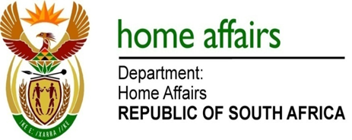

NATIONAL ASSEMBLY

QUESTION FOR WRITTEN REPLY

QUESTION NO. 2074

DATE OF PUBLICATION: MONDAY, 7 AUGUST 2017

INTERNAL QUESTION PAPER 25 OF 2017

2074. Ms H O Hlophe (EFF) to ask the Minister of Home Affairs:

Whether (a) her department and/or (b) any entities reporting to her are funding, including by way of discretionary funding, any institution of research and development (i) domestically and/or (ii) internationally; if so, (aa)(aaa) what are the names of the specified institutions and (bbb) what are their functions, (bb) from what date has her department or any entity reporting to her been funding them and (cc) what amount has her department contributed towards such funding? NW2296E
REPLY:

The Department and the entities responded as follows:

(a) Department of Home Affairs
(a)(i) No
(a)(ii) No

(aa)(aaa) N/A
(bbb) N/A
(bb) N/A
(cc) N/A

(b) Government Printing Works
(b)(i) No
(b)(ii) No

(aa)(aaa) N/A
(bbb) N/A
(bb) N/A
(cc) N/A

(b) Electoral Commission
(b)(i) No
(b)(ii) No

(aa)(aaa) N/A
(bbb) N/A
(bb) N/A
(cc) N/A

