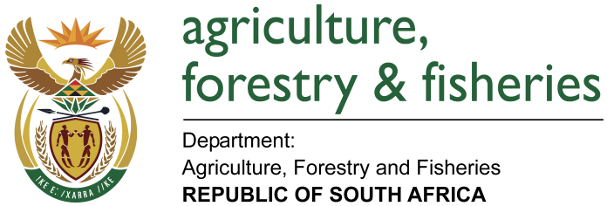

NATIONAL ASSEMBLY

WRITTEN REPLY

QUESTION 2046 / NW2357E

MINISTER OF AGRICULTURE, FORESTRY AND FISHERIES:
MR A M FIGLAN (DA) TO ASK THE MINISTER OF AGRICULTURE, FORESTRY AND FISHERIES

QUESTION:
(1) Whether each Head of Department (HOD) of his department signed a performance agreement since their appointment; if not, (a) what is the total number of HODs who have not signed performance agreements, (b) what is the reason in each case, (c) what action has he taken to rectify the situation and (d) what consequences will the specified HOD face for failing to sign the performance agreements; if so, (i) when was the last performance assessment of each HOD conducted and (ii) what were the results in each case;

(2) Whether any of the HODs who failed to sign a performance agreement received a performance bonus since their appointment; if not, what is the position in this regard; if so, (a) at what rate and (b) what criteria were used to determine the specified rate;

(3) Whether any of the HODs who signed a performance agreement received a performance bonus since their appointment; if so, (a) at what rate and (b) what criteria were used to determine the rate?

REPLY:

- Whether each Head of Department (HOD) of his department signed a performance agreement since their appointment; if not,
- What is the total number of HODs who have not signed performance agreements?
The Director-General of the Department of Agriculture, Forestry and Fisheries was appointed with effect from 1 July 2016. In terms of the chapter four (4) of the Senior Management Service (SMS) members handbook a newly appointed SMS member has got three months to finalise and sign the performance agreement.

- What is the reason in each case?
The HOD had three months to finalise the performance agreement.
- What action has he taken to rectify the situation?
None.
(d) What consequences will the specified HOD face for failing to sign the performance agreements; if so,
(i) When was the last performance assessment of each HOD conducted?
The performance assessment on the former HOD was finalised in December 2015.
(ii) What were the results in each case?
The performance scores of the former HOD were as follows:
- 2013/14 performance cycle score of 132%.
- 2014/15 performance cycle score of 135%.

- Whether any of the HODs who failed to sign a performance agreement received a performance bonus since their appointment; if not, what is the position in this regard; if so,
- At what rate and
The HOD did not receive a performance bonus.
- What criteria were used to determine the specified rate;
Not applicable.

- Whether any of the HODs who signed a performance agreement received a performance bonus since their appointment; if so,
- At what rate and
The HOD did not receive a performance bonus.
- What criteria were used to determine the rate?
Not applicable.

