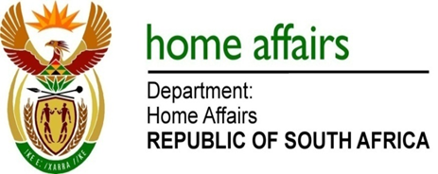

NATIONAL ASSEMBLY

QUESTION FOR WRITTEN REPLY

QUESTION NO. 2028

DATE OF PUBLICATION: FRIDAY, 30 JUNE 2017

INTERNAL QUESTION PAPER 24 OF 2017

2028. Mr M H Hoosen (DA) to ask the Minister of Home Affairs:

What number of (a) applications for South African citizenship did her department receive (i) in the (aa) 2014-15, (bb) 2015-16 and (cc) 2016-17 financial years and (ii) since 1 April 2017 and (b) the specified applications were (i) approved and (ii) declined in each case? NW2243E

REPLY:

(i)(aa - cc) As the Department reports on citizenship statistics on a calendar year basis, the information is as follows:
Applications for citizenship received in 2014 are 192.
Application for citizenship received in 2015 are 411.
Applications for citizenship received in 2016 are 454.
Applications for citizenship received in 2017 are 92 to date.

(b)(i) In 2014 there were 525 approvals.
In 2015 there were 603 approvals.
In 2016 there were 750 approvals.
In 2017 there were 403 approvals to date.

(b)(ii) In 2014 there were 31 disapproved.
In 2015 there were 13 disapproved.

In 2016 there were 35 disapproved.
In 2017 there were 43 disapproved to date.

NB: The department processed more applications than actual number received per year due to work carried over from one year to the following year.

