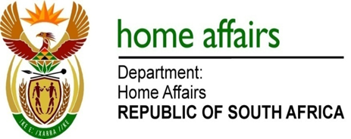

NATIONAL ASSEMBLY

QUESTION FOR WRITTEN REPLY

QUESTION NO. 2021

DATE OF PUBLICATION: FRIDAY, 30 JUNE 2017

INTERNAL QUESTION PAPER 24 OF 2017

2021. Ms B S Masango (DA) to ask the Minister of Home Affairs:

(1) (a) In how many events of the Integrated Community Registration Outreach Programme did her department participate in the 2016-17 financial year, (b) on what date did each event take place and (c) in which (i) province, (ii) municipality and (iii) ward did each event take place;
(2) whether her department incurred any costs to participate in the specified events; if so, what was the total amount incurred in respect of each event? NW2236E
REPLY:

(1-2) The information in respect of all nine provinces is attached.

