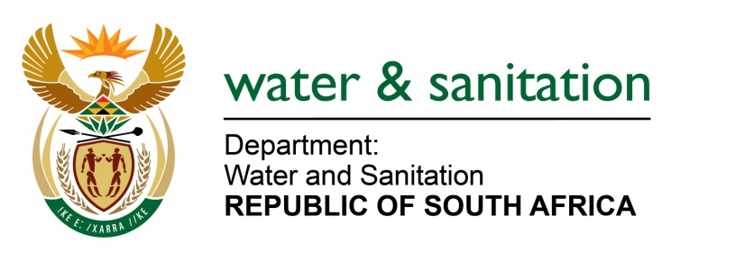

NATIONAL ASSEMBLY

FOR WRITTEN REPLY

QUESTION NO 1961

DATE OF PUBLICATION IN INTERNAL QUESTION PAPER: 16 SEPTEMBER 2016
(INTERNAL QUESTION PAPER NO. 28)

1961. Ms T E Baker (DA) to ask the Minister of Water and Sanitation:
(1) Whether, with reference to the appointment of a board and chairperson for the proposed merger of the Mhlathuze and Umgeni water boards, she required that a selection panel be constituted in terms of section 3(1) of Schedule 1 of the Water Services Act, Act 108 of 1997, as amended; if not, why not; if so, (a)(i) on what date and (ii) in which media were the relevant notices referred to in section 2(1) of Schedule 1 of the specified act published and (b) what are the further relevant details regarding constituting the specified panel in terms of the requirements set out in section 3(7) of Schedule 1 of the specified act;
(2) whether the specified panel received any nominations for board members; if not, why not; if so, (a) which nominees were included on the shortlist and (b)(i) when and (ii) where were the specified shortlisted nominees interviewed;
(3) whether the specified panel made any recommendations to her with regard to the proposed appointments (a) to the specified board and/or (b) of a chairperson; if not, why not; if so, what are the relevant? NW2272E
---00O00---
REPLY:
(1) The appointment of the new Board and the Chairperson for the single KwaZulu-Natal Water Board has not yet commenced. However, it should be noted that an Independent Transitional Committee was appointed to provide strategic guidance and oversight during the establishment process. The Independent Transitional Committee consists of representatives from the Department of Water and Sanitation, KwaZulu-Natal Premier’s Office, KwaZulu-Natal Cooperative Governance and Traditional Affairs, Chairperson of the Board of Umgeni Water and the Chairperson of the Board of Mhlathuze Water so as to ensure the successful establishment of the single Water Board in KwaZulu-Natal.
The Chairperson of the Board of Mhlathuze Water was appointed as the Chairperson of the Independent Transitional Committee and the Chairperson of the Board of Umgeni Water was appointed as the Deputy Chairperson of the Independent Transitional Committee. In addition, in terms of the Water Services Act, 1997 (Act No. 108 of 1997) (WSA) as amended, Schedule 1 Section 3(1) is not applicable to the appointment of the Independent Transitional Committee.
The requirements set out in Schedule 1 Section 3(7) of the Water Services Act, 1997 (Act No. 108 of 1997) (WSA) as amended, is not applicable to the appointment of the Independent Transitional Committee.
(2) There is no new Board and Chairperson appointed for the single KwaZulu-Natal Water Board. The Independent Transitional Committee consists of representatives from the Department of Water and Sanitation, KwaZulu-Natal Premier’s Office, KwaZulu-Natal Cooperative Governance and Traditional Affairs, Chairperson of the Board of Umgeni Water and the Chairperson of the Board of Mhlathuze Water.
(3) Refer to answer in point (1) and (2) above.
---00O00---

