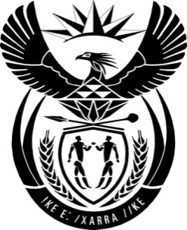

THE PRESIDENCY: REPUBLIC OF SOUTH AFRICA
Private Bag X1000, Pretoria, 0001
NATIONAL ASSEMBLY
QUESTIONS FOR WRITTEN REPLY

QUESTION NO: 1806.

Date Published:

Mr D J Maynier (DA) to ask the President of the Republic:

Whether, in the light of his statement on 2 September 2016 distancing himself from the announcement of the Minister of Mineral Resources, Mr Mosebenzi Zwane concerning the work of the task team established to consider the implications of the decision of certain banks and audit firms to close the accounts and withdraw audit services from Oakbay Investments (Pty) LTD, he will take action against the Minister; if not, why not; if so, (a) what action will he take and (b) when will such action be taken? NW2114E

Reply:
The statement issued by the Minister of Mineral Resources, Mr Mosebenzi Zwane on 1 September 2016, on the work of the task team established to consider the implications of the decisions of certain banks and audit firms to close down the accounts and withdraw audit services from the company named Oakbay Investments, was issued in his personal capacity and not on behalf of the task team or Cabinet.

I reassured the public, the banking sector as well as domestic and international investors of Government’s unwavering commitment to the letter and spirit of the country’s Constitution as well as in the sound fiscal and economic fundamentals that underpin our economy.
I also informed parliament on 13 September that I was engaging Minister Zwane regarding his statement.

