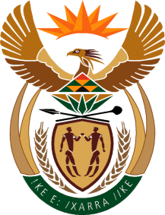

MINISTRY OF TOURISM
REPUBLIC OF SOUTH AFRICA

Private Bag X424, Pretoria, 0001, South Africa. Tel. (+27 12) 444 6780, Fax (+27 12) 444 7027
Private Bag X9154, Cape Town, 8000, South Africa. Tel. (+27 21) 469 5800, Fax: (+27 21) 465 3216

Ref: TM 2/1/1/10

NATIONAL ASSEMBLY:

QUESTION FOR WRITTEN REPLY:
Question Number: 1776
Date of Publication: 9 June 2017
NA IQP Number: 21
Date of reply: 22 June 2017

Mr M W Rabotapi (DA) to ask the Minister of Tourism
Does (a) she, (b) her Deputy Minister or (c) any of the heads of entities or bodies reporting to her make use of security services paid for by the State for (i) him/herself, (ii) his/her immediate family members or (iii) any of their staff members; in each case (aa) what are the reasons for it, (bb) from which department or entity’s budget is the security services being paid, and (cc) what are the relevant details? NW1982E Reply:
 | - Minister | - Deputy Minister | - Head of entity (SAT) or bodies
- Herself | No | No | No
- Her immediate family members | No | No | No
- Any of their staff members | No | No | No

(aa) What are the reasons for it?
Not applicable
(bb) From which department or entity’s budget is the security services being paid?
Not applicable
(cc) What are the relevant details?
Not applicable

