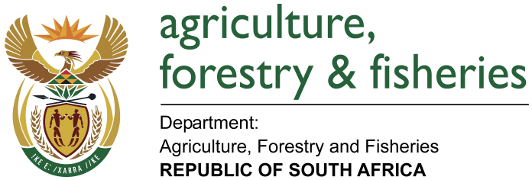
NATIONAL ASSEMBLY

WRITTEN REPLY

QUESTION 1717 / NW1966E

MINISTER OF AGRICULTURE, FORESTRY AND FISHERIES:
INKOSI R N CEBEKHULU (IFP) TO ASK THE MINISTER OF AGRICULTURE, FORESTRY AND FISHERIES

QUESTION:

Can he provide full details with regard to which department the welfare of captive bred animals such as lions lies? NW1966E

REPLY:

The care and protection of animals in South Africa is regulated by two Acts — the Animal Protection Act, (APA) 1962 (Act 71 of 1962) (APA) and the Performing Animal Protection Act, (PAPA) 1935 (Act 24 of 1935) (PAPA) under the Department of Agriculture, Forestry and Fisheries (DAFF) A third Act, the Societies for the Prevention of Cruelty to Animals Act (Act No. 169 of 1993) governs the organization and management of the SPCA movement in South Africa.

DAFF is publishing Draft Norms and Standards for the Welfare of Captive Lions under Animals Protection Act, 1962 (Act 71 of 1962) to enforce welfare prescripts regarding lions in captivity.

