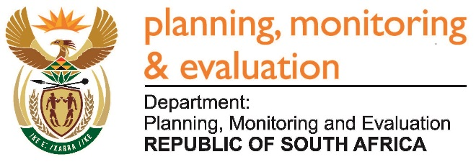 |  | 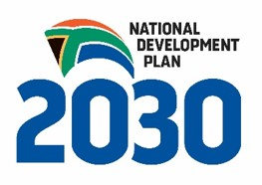
Private Bag X944, PRETORIA, 0001. Union Buildings East Wing, Government Avenue, PRETORIA
Tel: 012 312 0307. www.dpme.gov.za

[No 22—2016] THIRD SESSION, FIFTH PARLIAMENT
______________________
NATIONAL ASSEMBLY

1686. Mr J Selfe (DA) to ask the Minister in The Presidency:
Whether he requested any form of (a) legal advice and/or (b) advisory services from a certain firm of attorneys (name and details furnished) with regard to the Public Protector’s reports entitled (i) Secure in Comfort, report No 25 of 2013/14, (ii) Inappropriate Moves, report No 13 of 2013/14 and (iii) When Governance and Ethics Fail, report No 23 of 2013/14; if so, in each case, (aa) in which specific financial years were the services rendered and (bb) what was the cost of the services? NW1899E

REPLY:

No.

