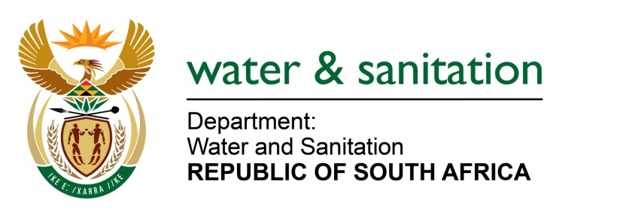

NATIONAL ASSEMBLY

FOR WRITTEN REPLY

QUESTION NO 1678

DATE OF PUBLICATION IN INTERNAL QUESTION PAPER: 19 AUGUST 2016
(INTERNAL QUESTION PAPER NO. 20)

1678. Adv H C Schmidt (DA) to ask the Minister of Water and Sanitation:
Whether funding has been allocated to her department through the Division of Revenue Act, Act 3 of 2016, for the provision of regional bulk infrastructure for the Sedibeng Regional Sewerage Scheme in the Sedibeng District Municipality in Gauteng; if so, what amount has been budgeted for the specified scheme in the (a) 2016-17, (b) 2017-18 and (c) 2018-19 financial years? NW1890E
---00O00---
REPLY:

Yes the Department through Regional Bulk receive conditional grant allocated in terms of Division of Revenue Act, 2016 (Act No. 3 of 2016) (DoRA).
Sedibeng Regional Sewerage Scheme is allocated funding as follows:
(a) 2016/17 - R50 000 000.00
(b) 2017/18 – R64 200 000.00
(c) 2018/19 – R100 000 000.00
---00O00---

