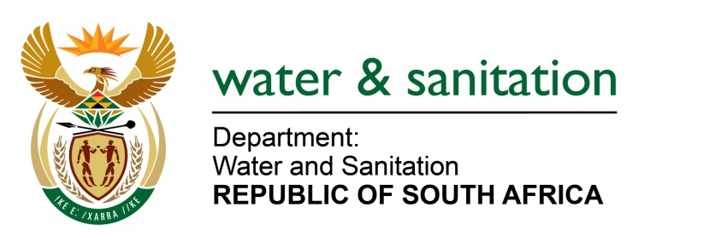

NATIONAL ASSEMBLY

FOR WRITTEN REPLY

QUESTION NO 1667

DATE OF PUBLICATION IN INTERNAL QUESTION PAPER: 9 JUNE 2017
(INTERNAL QUESTION PAPER NO. 21)

1667. Mr L J Basson (DA) to ask the Minister of Water and Sanitation:
What is the (a) name, (b) location, (c) nature of work done and (d) total cost of each dam safety project undertaken by a certain company (name furnished) in each of the past five financial years? NW1873E
---00O00---
REPLY:

Refer to the table below for the name, location, nature of work done and total cost of each dam safety project undertaken by Sigodi Marah Martin Management. The total project cost stated in the table below is for the execution of the works (i.e design costs and construction costs). Sigodi Marah Martin Management was appointed in November 2013 to October 2016 on a time cost basis contract.
---00O00---

NO. | PROVINCE | NAME OF PROJECT | NATURE OF WORK / REHABILITATION SCOPE OF WORK | TOTAL PROJECT COST | SIGODI MARAH MARTIN - SCOPE OF WORK
1. | Eastern Cape | Elandsdrift Barrage | Rehabilitation of the auxiliary spillway and mechanical gates (radial gates) | R 312 232 338 | Approved Professional Person
2. | Eastern Cape | Cata Dam | Refurbishment of the outlet works and rehabilitation of earth embankment. | R 50 612 689 | Project Management & Approved Professional Person
3. | Limpopo | Chuenispoort Dam | Rehabilitation to address slope instability of the earth embankment& mechanical refurbishment | R 120 392 232 | Project Management (Mechanical works only)
4. | Eastern Cape | Mnyameni Dam | Refurbishment of the outlet works and rehabilitation of earth embankment. | R 21 154 201 | Project Management & Approved Professional Person
5. | Eastern Cape | Ncora Dam | Rehabilitation of twin 1,8 m diameter concrete pipes | R 1 654 462 | Project Management
6. | North West | Rietspruit Dam | Rehabilitation to address slope instability of the earth embankment | R 3 763 305 | Project Management
7. | Limpopo | Mashashane Dam | Rehabilitation of the earth embankment | R 21 595 394 | Site supervision
8. | Free State | Orange-Riet Dam | Increasing storage capacity of the balancing dam | R 273 599 750 | Project Management
9. | North West | Taung Dam | Mechanical refurbishment of the outlet works | R 20 467 225 | Project Management & design optimisations of mechanical outlets
10. | Western Cape | Stompdrift Dam | Rehabilitation of the concrete arch component of the dam | R 98 004 332 | Project Management (Mechanical works only)
11. | Limpopo | Nsami Dam | Increasing the spillway capacity of the dam & mechanical refurbishment | R 154 642 237 | Project Management& design optimisations of mechanical outlets
12. | Eastern Cape | Kouga Dam | Geotechnical investigations and monitoring of the dam’s micro movement. | R 3 321 556 | Structural Safety Analyses (Ambient Vibration Monitoring)
13. | Limpopo | Vaalkop II Dam |  | R 92 014 083 | Approved Professional Person
14. | Free State | Welbedacht | Mechanical refurbishment of the inlet and outlet works. | R 12 416 710 | Project Management & design optimisations of mechanical outlets.
15. | Various Provinces | - Gariep Dam  - Kogelberg Dam  - Greater Brandvlei Dam  - Rockview Dam  - Welbedacht Dam  - Heyshope Dam  - Morgenstond Dam  - Tshakuma Dam. | Compilation of 5 yearly Dam Safety EvaluationsforCategory III Dams. |  | Approved Professional Person

Sigodi Marah Management’s expenditure per financial year is as follows:
- 2013/14 – R 3 418 333.04
- 2014/15 – R 20 935 669.35
- 2015/16 – R 58 223 703.77
- 2016/17 – R 1 632 465.35

---00O00---

