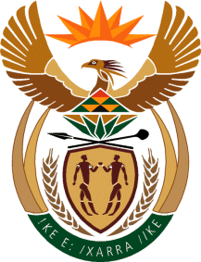

MINISTRY OF TOURISM
REPUBLIC OF SOUTH AFRICA

Private Bag X424, Pretoria, 0001, South Africa. Tel. (+27 12) 444 6780, Fax (+27 12) 444 7027
Private Bag X9154, Cape Town, 8000, South Africa. Tel. (+27 21) 469 5800, Fax: (+27 21) 465 3216

Ref: TM 2/1/1/10

NATIONAL ASSEMBLY:

QUESTION FOR WRITTEN REPLY:
Question Number: 1642
Date of Publication: 9 June 2017
NA IQP Number: 21
Date of reply: 22 June 2017

Mr G R Krumbock (DA) to ask the Minister of Tourism

Whether she has established the reasons for the 11% increase in spending per day on domestic trips in 2016 compared to 2015, even though SA Tourism reports that affordability is the main deterrent to taking a trip; if so, what are the relevant details? NW1848E

Reply:

The increase in average spend per day was driven by increased spend towards transport and shopping for personal usage among others.

