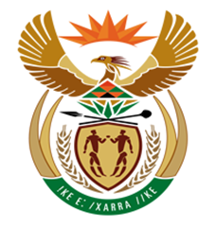

NATIONAL ASSEMBLY

QUESTION FOR WRITTEN REPLY
QUESTION NUMBER: 1618 [NW1823E]
DATE OF PUBLICATION: 9 JUNE 2017

1618. Mr R A Lees (DA) to ask the Minister of Finance:
(1) Whether any outstanding value-added tax (VAT) refunds were due from the SA Revenue Service (SARS) to a certain company (OAKBAY ENTERPRISES) for each of the past three tax years; if so,
(2) whether any VAT refunds were paid to the specified company in 2017; if so, (a) what amount of the VAT refund was paid and (b) into which bank account was the VAT refund paid;
(3) whether the value-added tax refund paid to a certain company (name furnished) was audited; if so, what time period did it take SARS to audit the VAT refund;
(4) whether the bank account in which the refund was paid was verified as belonging to the specified company in that the company furnished SARS with copies of identification documents, stamped letters from the bank and proof of address; if not, why not; if so, what are the relevant details;
(5) whether any legal advice was sought on the legal ramifications of SARS paying the specified refund; if not, why not; if so, (a) what are the relevant details of the legal opinions obtained from (i) the legal advisors of SARS and (ii) any external legal advisors and (b) were these legal opinions taken into account when the decision was taken to effect the refund payment? NW1823E
REPLY:

The South African Revenue Service is, in terms of the provisions of Chapter 6 of the Tax Administration Act, bound to treat all taxpayers’ affairs as confidential and may not divulge any aspects pertaining to the affairs of any taxpayer.

The Commissioner can therefore not divulge any details relating to this matter.

