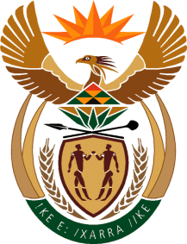

MINISTRY OF TOURISM
REPUBLIC OF SOUTH AFRICA

Private Bag X424, Pretoria, 0001, South Africa. Tel. (+27 12) 444 6780, Fax (+27 12) 444 7027
Private Bag X9154, Cape Town, 8000, South Africa. Tel. (+27 21) 469 5800, Fax: (+27 21) 465 3216

Ref: TM 2/1/1/10
NATIONAL ASSEMBLY:
QUESTION FOR WRITTEN REPLY:
Question Number: 1530
Date of Publication: 20 May 2016
NA IQP Number: 16
Date of reply: 26 May 2016

Mr Y Cassim (DA) to ask the Minister of Tourism:
(1) Whether his department was approached by any political party for any form of funding (a) in the (i) 2013-14, (ii) 2014-15 and (iii) 2015-16 financial years and (b) since 1 April 2016; if so, what are the relevant details in each case;
(2) whether his department provided any form of funding to any political party (a) in the (i) 2013-14, (ii) 2014-15 and (iii) 2015-16 financial years and (b) since 1 April 2016; if not, what is the position in this regard; if so, what are the relevant details in each case? NW1701E
Reply

(1) (a) (i) No
(ii) No
(iii) No

(b) Not applicable

(2) (a) (i) No
(ii) No
(iii) No

(b)The Department of Tourism does not make provision for gifts, donations or sponsorships in its Estimate of National Expenditure. Any requests from any organisation is dealt with in accordance with Treasury Regulation 21.1.1 in that gifts, donations or sponsorships can only be approved if they are in the interest of the state.

