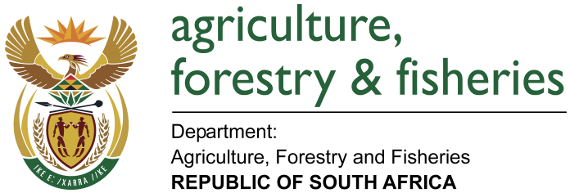
NATIONAL ASSEMBLY

WRITTEN REPLY

QUESTION 1398 / NW1540E

MINISTER OF AGRICULTURE, FORESTRY AND FISHERIES:

MR G G HILL-LEWIS (DA) (DA) TO ASK THE MINISTER OF AGRICULTURE, FORESTRY AND FISHERIES

QUESTION:

Are there any current impediments to the export of South African (a) meat and (b) animal related products, including eggs, to the European Union, relating to the failure by the country to renew its Approved Residue Plan; if so, what (i) are the relevant details and (ii) is being done to resolve these impediments? NW1540E

REPLY:
- and (b) No. There are no impediments to the export of South African meat, animal related products to the European Union (EU) relating to the failure by the country to renew its approved residue plan.

South Africa submitted the National Chemical Residue Control Programme to the EU on 11 April 2017. However, there were challenges identified during the recent audit carried out by the EU in South Africa in February 2017.

The challenges are being addressed with all relevant stakeholders and the EU is continuously being apprised of the developments. The Department is currently sourcing funding to implement a full National Chemical Residue Control Programme. Furthermore the Department and the Red Meat Industry Forum are discussing the possibility of launching a Public Private Partnership on residue monitoring. The results of the project and resultant outcomes are expected at the end of June 2017.

