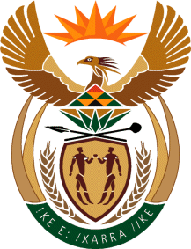
MINISTRY: SPORT AND RECREATION
REPUBLIC OF SOUTH AFRICA

Private Bag X869, Pretoria, 0001, Tel: (012) 304 5158, Fax: (012) 323 8426
Private Bag X9149, Cape Town, 8000, Tel: (021) 465 5506/7/8/9, Fax: (021) 465 4402

136. Mr T W Mhlongo (DA) to ask the Minister of Sport and Recreation:

(1) Will South Africa be hosting the 2022 Commonwealth Games; if not, why not; if so,

(2) (a) is Durban still the host city, (b) has funding been committed to allow Durban to host the games, (c) has South Africa met all deadlines and obligations set by the Commonwealth Games Federation (CGF), (d) did he sign the financial guarantee requested by the CGF and (e) has the first Municipal Infrastructure Grant been allocated;

(3) what are the deliverables of the Board of the SA Sports Confederation and Olympic Committee;

(4) what amount is the specified event expected to cost (a) Durban, (b) KwaZulu-Natal and (c) the Government? NW141E

REPLY
we are sourcing some information from Durban, (b) KwaZulu-Natal, regarding the information requested. Information is not readily available

​​

