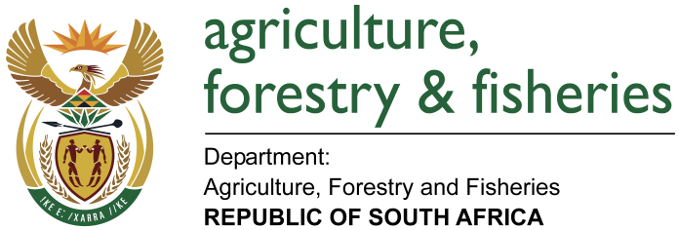
NATIONAL ASSEMBLY

WRITTEN REPLY

QUESTION 1210 / NW1351E

MINISTER OF AGRICULTURE, FORESTRY AND FISHERIES:
Mr H C C Krüger (DA) to ask the Minister of Agriculture, Forestry and Fisheries:

QUESTION:
Whether (a) his department and (b) each entity reporting to him has (i) procured any services from and/or (ii) made any payments to the Decolonisation Foundation; if not, in each case, what is the position in this regard; if so, what (aa) services were procured, (bb) were the total costs, (cc) is the detailed breakdown of the costs, (dd) was the total amount paid, (ee) was the purpose of the payments and (ff) is the detailed breakdown of the payments in each case? NW1351E

REPLY:

DAFF
DAFF has not procured any services from and/or made any payments to the Decolonisation Foundation.

PPECB
PPECB has not procured any services from and/or made any payments to the Decolonisation Foundation.

OBP
OBP has not procured any services from and/or made any payments to the Decolonisation Foundation.

NCERA
NCERA has not procured any services from and/or made any payments to the Decolonisation Foundation.

ARC
ARC has not procured any services from and/or made any payments to the Decolonisation Foundation.

NAMC
NAMC has not procured any services from and/or made any payments to the Decolonisation Foundation.

MLRF
Marine Living Resources Fund (MLRF) has not procured any services from and/or made any payments to the Decolonisation Foundation.

