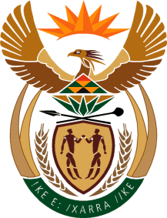

MINISTRY OF TOURISM

REPUBLIC OF SOUTH AFRICA

Private Bag X424, Pretoria, 0001, South Africa. Tel. (+27 12) 444 6780, Fax (+27 12) 444 7027

Private Bag X9154, Cape Town, 8000, South Africa. Tel. (+27 21) 469 5800, Fax: (+27 21) 465 3216

Ref: TM2/1/1/10
NATIONAL ASSEMBLY:

QUESTION FOR WRITTEN REPLY:
Question Number: 1187
Date of Publication: 22 April 2016
NA IQP Number: 12
Date of reply: 25 April 2016

Mr J Vos (DA) to ask the Minister of Tourism:

Whether he travelled with the President, Mr Jacob G Zuma, and other Ministers to Dubai in March 2016 to promote South Africa as a tourism destination; if not, what are the reasons for not joining the delegation which reportedly travelled to Dubai to promote South Africa as a tourism destination; if so, (a) for how many days was he in Dubai, (b) what are the details of the official business conducted in Dubai and (c) what were the outcomes of the specified trip? NW1327E
Reply:

The Minister did not form part of the President’s delegation to Dubai in March 2016.

- N/A

- N/A

- N/A

