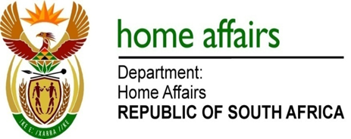

NATIONAL ASSEMBLY

QUESTION FOR WRITTEN REPLY

QUESTION NO. 1020

DATE OF PUBLICATION: THURSDAY, 29 MARCH 2018

INTERNAL QUESTION PAPER 10 OF 2018

1020. Mrs H O Mkhaliphi (EFF) to ask the Minister of Home Affairs:

Whether, with reference to his reply to question 221 on 27 February 2018, his department has financially compensated Ms Kamogelo Lena Maine and Ms Tseleng Joyce Maine, following his department’s error of swopping the birth registration forms of their children at Schweizer Reneke Hospital? NW1113E

REPLY:

No. The matter was amicably resolved on 20 February 2018.

