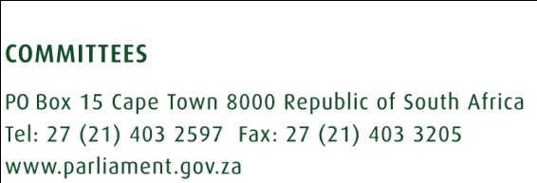
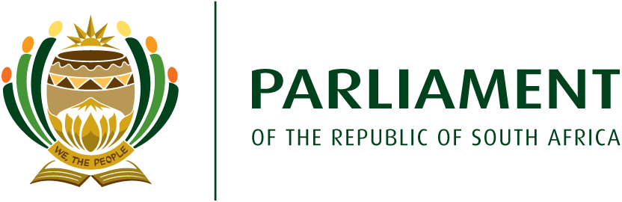
AUGUST 2017

SUMMARY OF THE FOCUS AREAS FOR THE NATIONAL PARLIAMENT COMMONWEALTH WOMEN PARLAIMENTARIAN CHAPTER
- Introduction
The South African National Parliament CWP chapter was launched on 06 March 2017. A strategic planning workshop was held on 20 June 2017 in order to identify priority areas that the chapter will focus on. Due to the short term duration of the chapter an agreement was reached to focus on few areas to ensure and maximise chances of success before the end of the Fifth Parliament.
- Identified focus areas
The following were identified as areas to focus on by the chapter:
- To focus on increasing the number of women represented and participating in politics.
- To focus on re- introduction of gender responsive budgeting.
- To focus on violence against women.
- To focus on women and health with particular focus on cancer.

- Identified activities in each focus area

  - Increase in number of women in politics
- Lobby and advocate IEC to review and amend the Electoral Act before 2019 elections.
- Engage political parties to adopt voluntary gender quotas and encourage male comrades to be champions of gender equality as per the HeforShe campaign.
- Make politics attractive to young women by hosting regular dialogues with female political studies students
- Another way marketing politics identified is the profiling of all women who have been Members of Parliament since 1994.
- Regular host social events to make current women Members of Parliament excited about the chapter,
- Developing a political alumni of former women Members of Parliament and encourage current MP to regularly interact with them in order to seek their wisdom and experience.

  - Gender responsive budgeting
- Engage with National Treasury about re- introduction of GRB
- Engage with the Speaker’s forum through the Deputy Speaker of the National Assembly about current efforts by the Speakers’ forum with regards to GRB
- To lobby and advocate for training of Members on GRB
- To engage with the Ministry of Women on the development of GRB framework

  - Gender based violence
- To host roundtable discussions with relevant Departments on GBV (including human trafficking and femicide).
- Forge and strengthen relations with NGO’s and CSO dealing with GBV.
- To engage women in traditional leaderships and the Commission for the Promotion and Protection of the Rights of Cultural, Religious and Linguistic Communities about cultural and religious practises contributing to violence against women.
- Social activism in the form of awareness raising and by conducting advocacy and outreach initiatives to various communities.
- Media coverage by regularly making pronouncements condemning violence against women and children.
- Raising of motions related to GBV in both Houses of Parliament.
- Lobbying and advocating for legal reform for various vulnerable groups where GBV is prevalent.

  - Women and health
- Host onsite screenings for cancer in Parliament
- Make presentations to Select and Portfolio Committee of Health about prioritising oversight over women and health issues especial cancer
- Continue to lobby and advocate for free provision of sanitary towels to indigent women.
- Conduct a study tour to a Country that has managed to removed VAT from sanitary towels and as well as provide free sanitary towels to girls.

